Abstract
This study investigates the factors that influence a song's popularity by analyzing audio features, genre and lyrical content using machine learning techniques. A unified dataset was constructed from multiple sources, including Spotify and AZLyrics, to extract relevant variables for prediction and pattern discovery. The project applies association rule mining to identify feature combinations linked to success or failure, builds a two-stage zero-inflated predictive model to estimate future popularity with enhanced accuracy, and analyzes lyrical sentiment and topics to uncover recurring trends. Results show that while predicting hit songs is inherently difficult due to data imbalance and shifting listener preferences, certain patterns, such as high danceability and emotional expressiveness, emerge as common in popular tracks. The findings offer interpretable, data-driven guidance for artists and producers seeking to optimize their creative output before release.
Index of contents
1. Introduction 1
2. Data preparation 1
2.1 Data sources and collection 1
2.2 Data cleaning 1
2.3 Minable View 3
3. Association rule mining for popular song characteristics 3
4. Predicting song popularity 4
4.1 Data Enhancement Model 5
4.2 Prediction Model 7
5. Embedding analysis for evolution of music preferences 13
6. Use of technology 17
7. Final conclusions 17
8. Legacy 17
9. Annex 19
9.1 Annex 1: Additional analysis of sentiments and topics of the lyrics 19
9.2 Annex 2: Additional word clouds from the lyrics 23
9.3 Annex 3: Additional association rules 26
9.4 Annex 4: Mock-up demonstration 27
10. Bibliography 27

1. Introduction
Music streaming platforms generate large amounts of data, which provides opportunities to analyze song characteristics and predict their popularity. This project aims to leverage machine learning techniques to predict a song's popularity based on its intrinsic features, create embeddings to account for listener-preferred expressions over time, and generate association rules that provide artists with insights into composing popular songs.
This document presents the final version of our project based on the analysis of different aspects of the world of music.

2. Data preparation

2.1 Data sources and collection
Additional data sources used (in addition to the original dataset provided by the professors) include:
- Spotify API: Provides data on audio features (Loudness, Tempo, etc.) and popularity metrics. It is also used to collect artists' genres for context.
- Kaggle Datasets: Offers databases like the one initially provided, with a primary focus on song popularity.
- Last.fm API: Provides genre tagging at the song level, improving classification granularity.
- AZLyrics Scraping: Enables the retrieval of song lyrics.
All data gathered from these sources has been cleaned and integrated to support a more effective analysis of the results.

2.2 Data cleaning
The main dataset integrates the 2021 data (originally provided) with equivalent data from 2024 and the popularity of its songs as of 2025. Notably, it focuses on 2021 and 2024 songs due to API limitations and query blocking.
Before starting, and to facilitate the concatenation of the tables from both years, these tables were loaded separately, and popularity columns were created for the non-recorded year (2024 if the data came from 2021 and vice versa).
Beginning with data definition, the 2024 dataset initially contained only audio features and song IDs, lacking information on song titles and artists. To address this, supplementary metadata was retrieved using the Spotify API. Once 2024 and 2021 had the same variables, an additional query was performed to obtain the current popularity value of each audio file, classifying it as popularity_2025. Thus, each song in the final dataset includes its popularity for the corresponding year (2021 or 2024) and the most recent popularity value (2025). If the same song appeared in both 2021 and 2024, the popularity value was calculated as the average of the popularity values from both years. To streamline the dataset and reduce the number of API queries, duplicate song IDs in the same year were identified and systematically removed.
Secondly, a discretization of the popularity values was carried out to facilitate future association rule generation. The following classes and their respective popularity thresholds were defined as FLOP (popularity ≤25), MID (25 < popularity ≤50), MID-HIT (50 < popularity ≤80), and HIT (popularity >80). Also, for the same purpose of enabling association rules, the remaining audio features were discretized, with categories and thresholds defined specifically for each one.
Next, genre acquisition for the songs was conducted, applying count-based filtering to avoid including genres with erroneous or extremely rare names. To retrieve genres for all songs, two different APIs were used: Spotify’s and Last.fm’s. The latter, offering song-level genre tagging instead of artist-level (as Spotify did), proved more useful. Unfortunately, Last.fm did not have information on all the songs studied, so missing entries were completed using artist-level data from Spotify. If no genre could be retrieved from both sources, the value was set to “Unknown”.
Finally, several basic data handling tasks were performed to complete the dataset cleaning:
- Column names were corrected to allow the concatenation of 2021 and 2024 datasets.
- Outliers with high Speechiness and names referring to podcasts/audiobooks were filtered out.
- Duplicate rows based on track_id were merged into a single row containing popularity values for 2021, 2024, and 2025.
- Genre naming errors were corrected to eliminate label duplication with minor variations (e.g., jpop → j-pop, hip hop → hip-hop).
In conclusion, the resulting database contains, for songs from 2021 and 2024: audio features, discretization of those features, popularity, discretization of popularity, title, artist(s), song ID, and genres.

2.3 Minable View
Once the previously described clean dataset was obtained, three subsets of specific variables were defined to develop the project's objectives. In this way, three mineable views of the project were generated:
- Popularity prediction: contains the values of the audio features, popularity across different periods, and genre labels. None of the variables underwent any special filtering.
- Genre prediction to enhance the main dataset: includes the same variables as the previous view. Furthermore, a filtering process was applied to retain only the most relevant genres within the dataset.
- Association rules: audio features, popularity, genres, and subgenres, with all variables in their categorized versions.

3. Association rule mining for popular song characteristics
This objective is based on identifying patterns that help both artists and record labels understand which combinations of song characteristics are more likely to succeed. Therefore, the creation of association rules is proposed to address this problem.
To carry out this section, a random subset of the data was used. The Apriori algorithm was then applied, setting different levels of categorized popularity (HIT, MID-HIT, MID, and FLOP) on the right-hand side of the rule, aiming to analyze how the characteristics vary at each popularity level. The analysis is focused on FLOP and HIT rules; the rules of the other popularity categories are in the Annex 3.
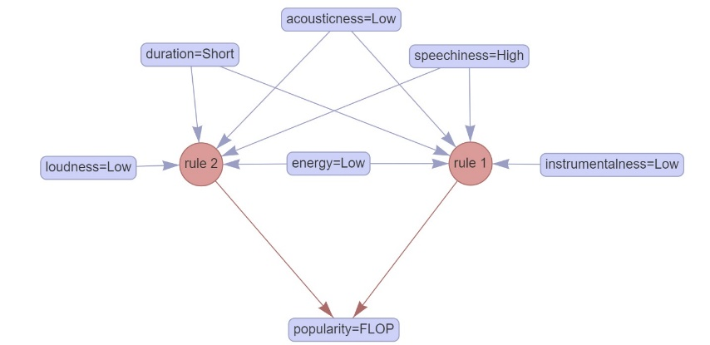
Figure 1 - Rules that have "FLOP" as consequent
Regarding the results, for example, it was observed that songs with high Speechiness, combined with low Energy, low Acousticness, and short Duration, have a high probability of being a FLOP.
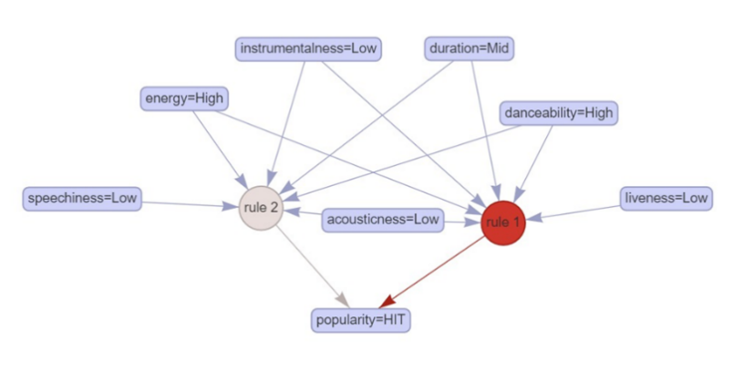
Figure 2 - Rules that have "HIT" as consequent
On the other hand, songs with high Danceability and high Energy are more likely to become a HIT. However, predicting a song's success with certainty remains difficult, as the number of truly successful tracks is very limited.
The evaluation of the association rules is based on support and confidence, as recommended during the seminar sessions. In general, the support for all the rules is quite low, as it is difficult to find songs with the same set of features. Additionally, it was observed that the confidence of the rules tends to decrease when analyzing songs with higher popularity, since the dataset contains relatively few tracks labeled as HIT or MID-HIT.
For example, the association rules for popularity = HIT have an approximate support of 0.12% (due to the low number of songs labeled as HIT) and a confidence of 0.6%. All of this leads to the conclusion that finding a combination of features that turns a song into a HIT is challenging.
On the other hand, the association rules defined for popularity = FLOP have a support of 10.16% and a confidence of 99.70%. This highlights the large number of songs labeled as FLOP. Therefore, these rules are expected to be more useful in helping artists understand which combinations of features in a song are generally disliked by listeners.

4. Predicting song popularity
This section focuses on developing models to predict a track’s popularity in 2025. The goal is not only to forecast popularity but also to extract actionable insights by understanding how each feature contributes to the prediction. By revealing the impact of individual audio, temporal, and genre attributes, it is possible to offer artists meaningful pre-release feedback, guiding their creative and production decisions. Further details on model construction and evaluation will follow in subsequent sections of this report.
Nonetheless, the dataset used for popularity prediction has many limitations that undermine model reliability—most notably a high proportion of tracks labeled “Unknown” in the main genre field, which obscures any meaningful link between genre and popularity. To address this, a two-phase approach is adopted: first, a data-enhancement classifier imputes or refines these missing genre labels using audio features; second, a prediction model is trained on the enriched dataset to forecast continuous popularity scores. This pipeline ensures that the final popularity estimates leverage cleaner, more informative inputs.

4.1 Data Enhancement Model
The main genre column offers valuable context, yet despite extensive API integration, a large share of tracks remain labeled “Unknown,” preventing any meaningful analysis of how genre influences popularity. To overcome this, an auxiliary classification model was developed which leverages audio and temporal features to impute these missing genre labels, focusing exclusively on the most prevalent categories. By assigning each song to a representative genre drawn from our top lists, this data-enhancement step produces a cleaner, more informative dataset—paving the way for more accurate and interpretable popularity forecasts in the subsequent stage.

Analysis
Five classification algorithms (Random Forest, XGBoost, SVM, Logistic Regression and KNN) were evaluated on this imbalanced genre‐label dataset. Overall classification accuracy served as the primary selection criterion for correctly assigning each track’s main genre. Additionally, macro‐averaged and weighted‐averaged F1 scores were assessed as secondary metrics to ensure robust performance across both frequent and rare genre categories.
Model | Accuracy | Macro Avg F1 | Weighted Avg F1
RandomForest | 0.61 | 0.48 | 0.57
XGBoost | 0.58 | 0.46 | 0.54
SVM | 0.60 | 0.50 | 0.58
LogisticRegression | 0.54 | 0.40 | 0.50
KNN | 0.53 | 0.42 | 0.52
Table 1 - Comparing metrics between models
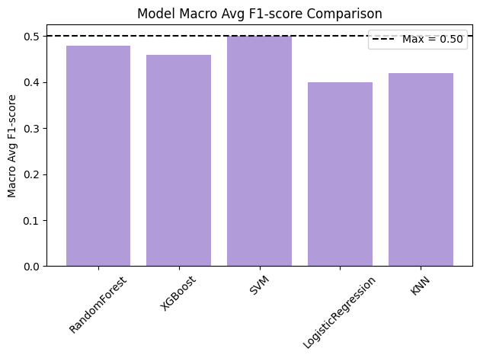
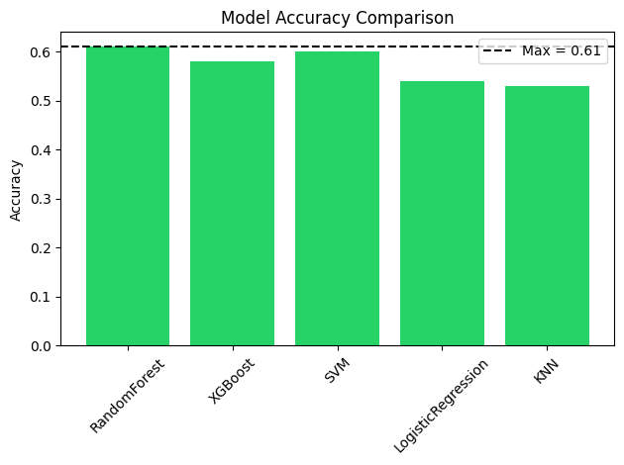
Figure 3 - Comparison of the accuracy among models Figure 4 - Comparison of the F1-score between models
A critical evaluation of overall accuracy (Figure 3) reveals that Random Forest achieves the highest score at 0.61, just edging out SVM’s 0.60. This margin, though small, underscores Random Forest’s capacity to capture complex interactions among audio features. XGBoost follows at 0.58, while Logistic Regression (0.54) and KNN (0.53) lag behind, suggesting that linear and distance-based methods struggle to generalize as effectively in this imbalanced setting.
When considering class balance explicitly through the macro-averaged F1-score (Figure 4), SVM leads with 0.50, indicating the best average performance across all genres, including minority classes. Random Forest closely follows at 0.48, demonstrating that its ensemble strategy maintains respectable sensitivity and precision even for underrepresented categories. XGBoost trails behind these top two, achieving an F1-macro of 0.46, while KNN (0.42) and Logistic Regression (0.40) again rank lowest, mirroring their weaker overall accuracy and confirming their relative unsuitability for this heavily imbalanced task.
The weighted-averaged F1-score exhibits the same ranking—SVM at 0.58 and Random Forest at 0.57—since it downweights minority noise and emphasizes dominant genres, underscoring that both ensemble methods retain strong performance when class support is considered. In contrast, Logistic Regression and KNN see larger declines, reflecting their poorer handling of skewed class distributions.
Taken together, the graphical and numerical comparisons illustrate a consistent pattern: ensemble and kernel-based methods (Random Forest and SVM) substantially outperform simpler linear or neighbor-based classifiers under heavy class imbalance. SVM shows a marginal edge in balancing precision and recall across all classes, but its overall accuracy falls just short of Random Forest’s peak score.

Model Selection
Balancing the dual aims of maximizing overall predictive accuracy and maintaining robust performance across genres, Random Forest is selected as the primary classifier for this tool. Although SVM edges out slightly in macro-averaged F1 (0.50 vs. 0.48), Random Forest’s higher overall accuracy (0.61) is crucial for reliably forecasting song popularity. Its parallelizable trees enable much faster training and inference compared to SVM’s nonlinear kernels, and with fewer hyperparameters to tune and built-in feature‐importance metrics, Random Forest eases both maintenance and model updates.
Because the genre-prediction model serves only to enhance the dataset rather than drive the main task, its interpretability is a lower priority; Random Forest’s “black-box” nature here can be accepted. Taken together, Random Forest not only meets the accuracy and class-balance requirements but also supports low inference latency and straightforward upkeep—making it the optimal choice for enriching genre labels.

Model generation and adjustments
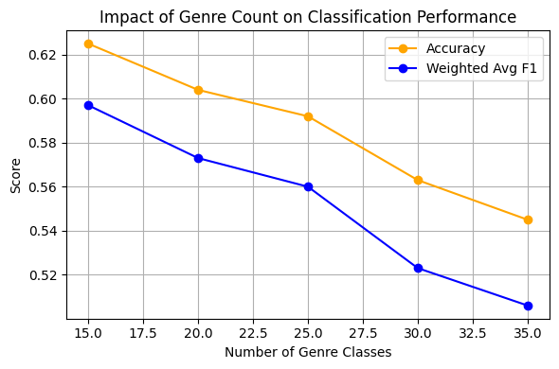
The Random Forest grid search identified the following optimal hyperparameter settings: bootstrap = True, criterion = “entropy”, max_depth = 40, max_features ≈ 0.22, and n_estimators = 300; which together yielded balanced‐training metrics of Accuracy = 0.63, F1 (weighted) = 0.60, and F1 (macro) = 0.52. This configuration strikes a strong balance between bias and variance, leverages approximately 22 % of features at each split to reduce overfitting, and employs enough trees (300) to stabilize predictions without prohibitive training cost.
Figure 5 - Metrics of Random Forest with different number of classes
Additionally, the number of predicted classes was tested across different genre counts (15, 20, 25, 30, and 35). Although increasing the number of categories may seem to provide finer-grained labeling, both accuracy and F1 metrics degrade rapidly beyond 15 classes, indicating a trade-off between classification detail and model reliability. Consequently, the original 15-genre setup remains the most appropriate balance for this application.

4.2 Prediction Model
Data‐enhancement steps imputed missing “Unknown” genre labels, paving the way for popularity prediction. The Spotify popularity target is heavily zero‐inflated, many tracks register zero popularity, then values spread continuously above zero. This distribution violates the Gaussian assumptions of standard regressors, which tend to overpredict zeros or underestimate the positive tail. As a result, single‐stage models produce biased estimates, poor calibration, and higher error, particularly in the “popularity > 0” regime that is most informative for decision‐making.
To address these challenges, a two‐part (or zero‐inflated) model is adopted that explicitly separates the zero‐mass generation from the continuous popularity process. First, a binary classifier distinguishes “zero” versus “non‐zero” popularity, optimizing F₁‐macro and recall ensuring robust detection of non‐zero tracks. Then, for observations predicted as non‐zero, a second‐stage regressor estimates the continuous popularity score between 1 and 100. This decomposition delivers several advantages: it respects the mixed discrete‐continuous nature of the data, improves predictive precision in the positive regime, and provides clear interpretive pathways for both classification and regression outputs. While the two‐stage approach introduces additional modeling complexity and requires careful thresholding, its benefits in bias reduction, calibration, and actionable insights make it the preferred framework for the song‐popularity prediction tool.
To address this main challenge a two-part (zero-inflated) model which separates zero-mass generation from continuous popularity is proposed. Firstly, prediction starts using a binary classifier to detect zero vs. non-zero tracks, optimized for F1-macro and recall. Secondly, the model applies a regressor to non-zero cases to estimate scores from 1 to 100. This split aligns with the data’s discrete–continuous nature, enhances accuracy in the positive domain, and clarifies interpretability. Despite added complexity and threshold tuning, reduced bias, improved calibration, and actionable outputs validate this framework.

Binary classification subtask

 | Accuracy | F1-Macro | Precision-Macro | Recall-Macro | ROC AUC | Time (s)
RF | 0.6903 | 0.6755 | 0.6743 | 0.6896 | 0.762 | 3.7462
XGB | 0.7178 | 0.6553 | 0.691 | 0.6482 | 0.7669 | 1.2981
GBC | 0.7182 | 0.6493 | 0.6947 | 0.6427 | 0.7622 | 0.7068
LR | 0.6843 | 0.5316 | 0.6858 | 0.562 | 0.6735 | 0.1782
Table 2 - Comparison of classification model performance
On the imbalanced binary task (171,775 total tracks, of which 112,368 are non-zero), Random Forest achieves the highest F₁‐Macro (0.6755) and Recall‐Macro (0.6896), demonstrating the strongest balance between precision (0.6743) and sensitivity on the minority “zero” class. XGBoost leads in ROC AUC (0.7669), reflecting superior ranking ability across thresholds, and posts solid Accuracy (0.7178) and Precision‐Macro (0.6910), although with a slightly lower F₁‐Macro (0.6553). Gradient Boosting (GBC) edges out RF on raw Accuracy (0.7182 vs 0.6903) and Precision‐Macro (0.6947), but its F₁‐Macro (0.6493) and ROC AUC (0.7622) remain below RF’s performance. Finally, Logistic Regression lags on every metric (Accuracy 0.6843, F₁‐Macro 0.5316, ROC AUC 0.6735) making it the least suitable for this zero‐inflated, class‐imbalanced setting.
In imbalanced binary classification, especially in the initial phase of a zero‐inflated pipeline where accurate separation of “zero” and “non‐zero” cases is critical, F₁‐Macro and Recall‐Macro serve as the primary evaluation metrics. These measures balance precision and recall equally and heavily penalize misclassification of the minority class. Random Forest’s superior F₁‐Macro and Recall‐Macro scores therefore reflect the most dependable threshold‐based discrimination. Its bagging architecture further enhances stability by reducing variance without introducing unnecessary complexity, making it well suited to the noisy, zero‐inflated data distribution.
Although XGBoost achieves the highest ROC AUC (advantageous for tasks that depend on probabilistic rankings) its lower F₁‐Macro compared to Random Forest indicates slightly less balanced labeling at a fixed decision threshold. Gradient Boosting (GBM) matches Random Forest in overall accuracy and even outperforms it in Precision‐Macro (0.6947 vs. 0.6743), yet GBM’s F₁‐Macro (0.6493) and ROC AUC (0.7622) remain below the Random Forest benchmarks. Given that the binary classifier’s foremost role is reliable zero‐vs‐non‐zero separation at a predetermined cutoff, F₁‐Macro and Recall‐Macro rightly overshadow broader ranking metrics in the model selection process.
Random Forest proves ideal for the zero‐vs‐non‐zero classifier by combining superior imbalanced‐class performance (highest F₁‐Macro and Recall‐Macro) with inherent transparency. Its bagged‐tree structure reduces variance and yields clear feature‐importance metrics, while direct SHAP integration supports both global and local explanations without the extra calibration required by many boosting methods. This balance of reliable minority‐class detection and straightforward interpretability ensures that every zero‐prediction can be reviewed and justified, meeting the needs of rigorous research and production environments alike.

Explainability of RandomForest
Feature | Importance
num__year | 0.224041
num__acousticness | 0.06528
num__loudness | 0.050123
num__duration_ms | 0.048025
num__speechiness | 0.046201
num__instrumentalness | 0.045878
num__energy | 0.041572
num__energy_valence | 0.039619
num__danceability | 0.039555
num__danceability_tempo | 0.039287
num__valence | 0.039239
num__liveness | 0.038118
num__tempo | 0.038013
num__key | 0.020959
num__month_cos | 0.019143
Table 3 – Importance of each variable in the RF model
The Random Forest’s global feature‐importance scores reveal that the release year (num__year) is by far the strongest predictor, accounting for roughly 22.4% of the model’s decision weight. Following this, a group of audio‐feature variables (acousticness, loudness, duration_ms, speechiness, instrumentalness and energy) contribute moderately (around 4–7%), indicating they carry meaningful but secondary signals in distinguishing zero‐popularity versus non‐zero‐popularity tracks. In contrast, features like tempo, key, and month_cos display importances below 4%, suggesting they play only a minor role in the binary classification.
However, these global importance metrics offer only a high‐level, superficial view of feature relevance. Random Forests are fundamentally “black‐box” ensembles, and aggregate importance scores can mask complex interactions and conditional dependencies among variables. For more precise, instance‐level explanations, such as understanding exactly which decision rules drove a particular track’s classification, one must inspect individual tree paths or leverage local interpretability methods (e.g. rule‐based tracing or local surrogate models) rather than relying solely on global importance rankings.

Regression subtask
 | RMSE | MAE | R2 | Time (s)
RF | 14.871112 | 11.724581 | 0.299426 | 17.3967
XGB | 14.770578 | 11.536209 | 0.308866 | 1.0064
GBM | 14.945273 | 11.739734 | 0.292421 | 0.3132
KNN | 16.497899 | 13.009001 | 0.137767 | 188.3543
Table 4 – Comparison of regression model performance

XGBoost attains the lowest Root-Mean-Squared Error (RMSE = 14.7706) and Mean Absolute Error (MAE = 11.5362), together with the highest coefficient of determination (R²=0.3089). These improvements, even if they appear numerically small, translate into more precise estimates of track popularity in the positive regime, which is critical for downstream tasks such as playlist optimization or recommender calibration in zero-inflated settings.
Although Gradient Boosting (GBM) offers the fastest single-run training (0.31 s) and nearly matches XGBoost in accuracy, its RMSE and MAE remain marginally higher (14.9453 / 11.7397). Random Forest, by contrast, requires over 17 seconds to train for only a modest gain over GBM. On the other hand, the KNN model remains by far in all metrics the worse model, given its characteristics it is advisable to reject the model due to its comparatively poor predictive performance and prohibitive computational cost.
XGBoost delivers the most compelling combination of accuracy and speed for our second‐stage regression. It achieves the lowest RMSE and MAE alongside the highest R² on the test set yet retrains in well under one second orders of magnitude faster than Random Forest and KNN. Furthermore, gradient‐boosted tree ensembles like XGBoost are extensively validated in the literature for zero-inflated count settings (routinely outperforming classical generalized linear models and random forests without imposing bespoke assumptions on the excess zeros) and XGBoost’s native integration with the SHAP framework enables both global feature‐importance bar charts and local force plots for transparent, additive explanations of individual predictions. This dual combination of state-of-the-art predictive robustness and rigorous interpretability firmly supports the decision to adopt XGBoost as the core engine of the continuous-popularity stage.

Explainability of the XGBoost Model
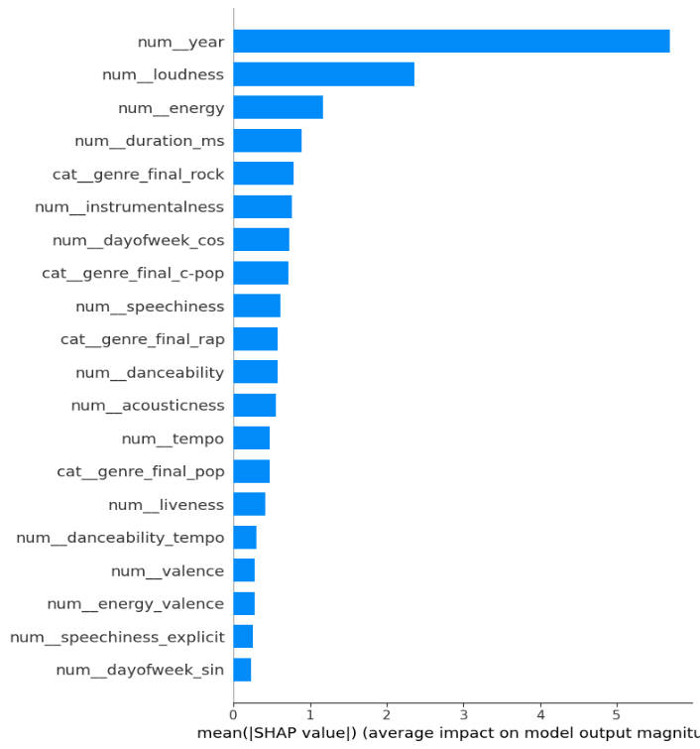
Figure 6 - Average impact of each feature on XGBoost’s output
The SHAP-derived mean absolute values (Figure 6) reveal that a small subset of variables dominates the model’s predictive power. Topping the list is num__year (5.70), indicating that release year exerts the strongest influence on predicted popularity. It is followed by num__loudness (2.36) and num__energy (1.16), both audio intensity measures. num__duration_ms (0.89) and the one-hot indicator cat__genre_final_rock (0.78) round out the top five most influential features. Together, these five variables are almost twice as impactful as the rest of the features, underscoring their critical role in the XGBoost classifier’s decision process.
At the opposite end of the spectrum lie features whose mean absolute SHAP values fall below 0.30. Among them, cat__genre_final_trance (0.038), cat__genre_final_female vocalists (0.032) and cat__season_Summer (0.031) contribute almost negligibly to model output. Notably, audio descriptors such as num__key (0.137) and num__mode (0.076), although semantically important for music theory, are effectively ignored by the model. This suggests that pitch class and modal information carry little predictive weight for popularity in our dataset.
The pronounced disparity between a handful of dominant features and a long tail of weak ones highlights the model’s reliance on temporal and intensity-based cues. Such a skewed importance distribution argues for streamlined models: focusing on year, loudness, energy, duration, and some genre indicators could preserve most predictive performance while drastically reducing dimensionality. Conversely, low-impact features might be pruned in future iterations to mitigate overfitting and improve computational efficiency.

Key findings
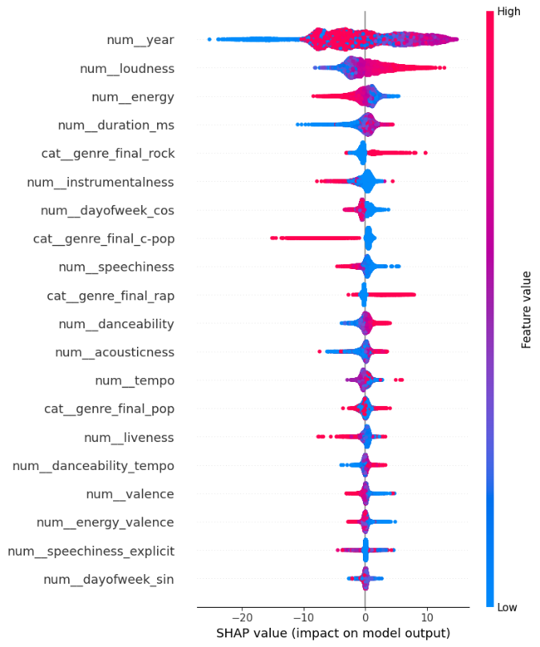
Figure 7 - SHAP values for the most impactful features
Release year emerges as the single most influential predictor, yet its SHAP pattern is non-monotonic. As seen in the plot above (Figure 7), older songs (blue points) strongly suppress predicted popularity, whereas very recent releases (red points) cluster around zero or even slight negative contributions, perhaps reflecting market saturation. Intriguingly, mid-range years (purple points) provide the strongest positive push, suggesting a “sweet spot” era whose nostalgia or production values resonate most with listeners. This nuanced relationship underscores the importance of modeling non-linear temporal effects.
Among audio descriptors, loudness displays a clear positive correlation: higher loudness values drive popularity predictions upward, while quieter tracks pull predictions downward. Energy shows a mirror-image effect. Surprisingly, highly energetic tracks sometimes decrease popularity, suggesting that excessive intensity may deter broader appeal. Other features such as acousticness, danceability, and speechiness exhibit more subtle, heterogeneous impacts: low acousticness and high danceability marginally boost popularity, whereas extreme speechiness tends to suppress it. Tempo appears bifurcated, with both very slow and very fast tempos offering modest gains but mid-range tempos exerting a mild negative effect.
Genre indicators reveal clear effects on predicted popularity. Rock tracks (cat__genre_final_rock) and rap songs both contribute positively, whereas C-Pop exerts a consistent downward influence. The Pop category displays considerable dispersion, suggesting sub-genre heterogeneity and context-dependent listener preferences. It can be posited, consistent with existing research, that genres defined by strong sonic signatures (e.g., distorted guitars or rhythmic vocal delivery) promote higher engagement and repeat plays, while mainstream pop may be more vulnerable to fleeting trends and individual moods.
Overall, this SHAP-guided analysis confirms that a small set of temporal and audio-intensity features, alongside key genre flags, suffices to capture the bulk of popularity variance in the cross-year song dataset. The XGBoost classifier leverages these cues to balance nostalgia, production dynamics, and stylistic affinity. Future work should explore dynamic modeling of release-year effects and investigate latent sub-genres within Pop. Nonetheless, these findings validate the zero-inflated, two-stage modeling approach and underscore the interpretability gains afforded by SHAP in music-popularity prediction.

5. Embedding analysis for evolution of music preferences
Another section of the project focuses on analyzing the most frequently repeated terms in songs with different levels of popularity. This guides artists by highlighting frequent words in hits and avoiding those linked to flops.
First, a script was developed to extract song lyrics by scraping the AZLyrics website. This platform was chosen due to the ease with which its URL could be generalized, requiring only the artist's name and the song title to access the lyrics. Lyrics were collected from all available datasets to date, corresponding to different time periods from the years 2018, 2019, 2021, 2023, 2024, and 2025.
Since the collected songs were in various languages, it was considered necessary to translate them all into English, as it is the majority language in the dataset. For this purpose, the langdetect library was employed to detect the original language of each song, and deep_translator was used to translate the lyrics into English. The result was a set of structured JSON files per year, where each file is organized as a dictionary: keys correspond to the original language of the songs, and values are lists of the translated lyrics.
Before proceeding to lexical analysis, all lyrics undergo a preprocessing stage. This included text cleaning and the expansion of common English contractions (e.g., “I'm” → “I am”, “don't” → “do not”). The idea behind this step is to standardize the linguistic structures, thereby improving the accuracy of part-of-speech tagging and enabling more reliable filtering of semantically meaningful terms such as nouns and adjectives.
Following preprocessing, sentiment analysis was conducted using the nltk (Natural Language Toolkit) library. Each song lyric was evaluated and classified as having either positive, negative or neutral sentiment (being the latter the result associated with the few songs from which no concise result was obtained). This classification enables a deeper understanding of lyrical content and its potential emotional impact, allowing for comparative analysis between popular and less popular songs based on sentiment polarity. The following image shows the results obtained.
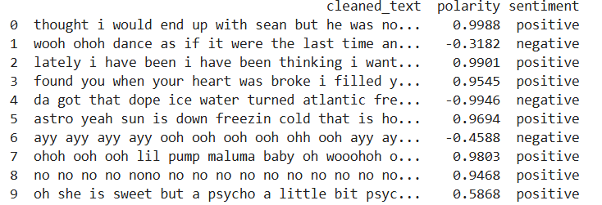
Figure 8 - cleaned_text column contains the preprocessed song lyrics, while polarity indicates the sentiment score
Another component of the objective involves identifying recurring topics within song lyrics using Latent Dirichlet Allocation (LDA). Although more advanced models like BERT offer higher granularity, they require significantly more computational resources and were unnecessary for the scope of this analysis. LDA was selected as a more efficient and interpretable alternative, providing meaningful topic distributions across the corpus of lyrics. The goal of this step is to uncover thematic patterns that characterize both popular and less popular songs, contributing to a broader understanding of lyrical trends. Here are the topics and the classification of the songs made by them.
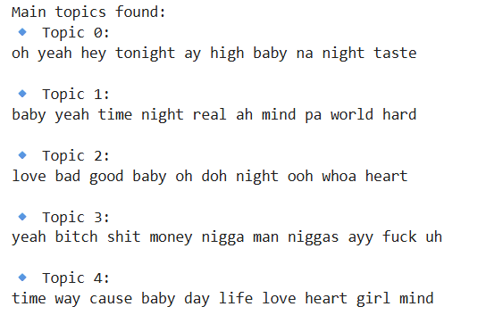
Figure 9 – Topics obtain by the LDA
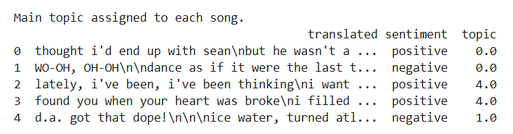
Figure 10 - Sample of the lyrics with sentiments and topics associated
Following topic modelling, several types of analyses were created. These include the evolution of sentiment over the years, the evolution of topics across different time periods, sentiment distribution by song popularity and topic distribution by popularity. Additionally, a cross-analysis of topics by popularity within each sentiment category was performed. Below are the results obtained regarding popularity, which is the main objective of the project. The remaining analyses are included as a curiosity in Annex 1.
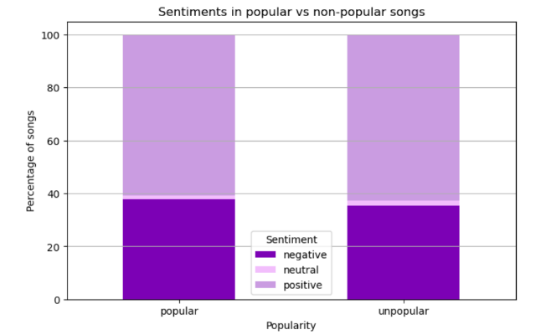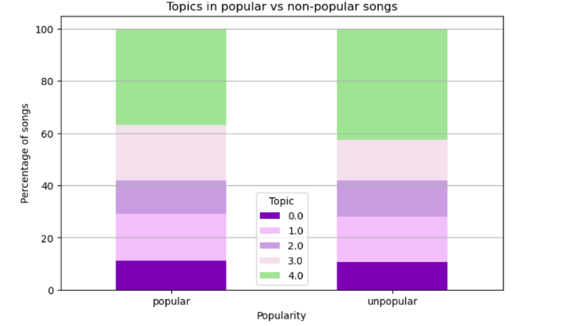
Figure 11 - Comparison of emotion by popularity Figure 12 - Comparison of topics by popularity
As can be observed, regarding the sentiments generated by a popular or a non-popular song, both groups display a comparable structure. Nevertheless, popular songs tend to contain a slightly higher proportion of negative answers and a lower incidence of positive ones. This may indicate a subtle association between negative emotional tone and song popularity.
In the case of topics, the chart displays the distribution of topics among popular and unpopular songs, as identified through LDA topic modelling. The relative frequency of each topic appears largely similar between the two groups, indicating that topic presence is not strongly differentiated by popularity. Nonetheless, minor variations in topic weight may hint at underlying preferences in thematic content that merit closer examination.
It's interesting to note how topic 3 (related to swear words) is most prominent in the most popular songs. Though further causality analysis should be made, this may lead one to think that this type of words can boost a song.
To conclude the analysis, word clouds were made to visualize the most frequently occurring terms identified in the previous steps. These provide an intuitive overview of the dominant vocabulary present in songs of varying popularity and sentiment, further reinforcing the findings of the lexical and topic analyses. As in the previous case, many graphs have been made for all the aspects studied throughout the project, but below only those most repeated words from the most and least popular songs will be shown. The rest of these representations will be shown in Annex 2.
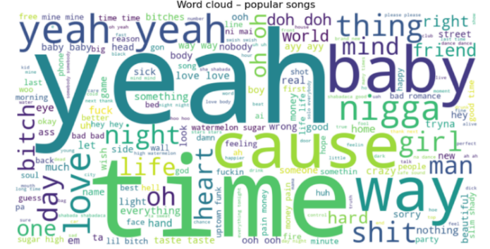
Figure 13 – Most common words in popular songs
In this case, it is shown the most frequently occurring words in popular songs. It is evident that informal expressions such as yeah, baby and cause dominate the lyrical content, reflecting a conversational and emotionally expressive tone. The prominence of terms related to relationships (love, girl, heart, friend, time) and “everyday language” suggests a focus on themes that are relatable and accessible to a broad audience, potentially contributing to the songs' popularity.
Again, it is observed that popular songs contain frequently repeated swear words, which may confirm the theory proposed above.
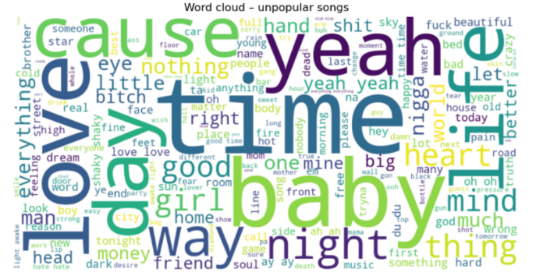
Figure 14 – Most common words in unpopular songs
Finally, this cloud represents the most frequent terms found in unpopular songs. Like popular tracks, words such as yeah, baby, time, and cause appear prominently, indicating a shared vocabulary base. However, there is a broader dispersion of thematically diverse terms, suggesting less lexical focus. While relational and emotional terms are still present, their lower emphasis may reflect a weaker connection with the themes that typically resonate more strongly with wider audiences.

6. Use of technology
The project utilized a variety of technologies across different stages of development. Python served as the core programming language, with libraries such as Pandas, NumPy, and Scikit-learn playing a central role in data processing. For machine learning tasks, the project employed TensorFlow, XGBoost, K-Means clustering, the Apriori algorithm, cuML, Random Forest, Support Vector Machines (SVM), Gradient Boosting, and additional functionality provided by Scikit-learn. Model interpretability was addressed using SHAP, while text analysis tasks relied on NLTK, langdetect, and Deep Translator. Association rule mining was carried out with the help of the Mlxtend library. Experimentation and development were conducted in Jupyter Notebooks, and Figma was used for mockup and prototype design.

7. Final conclusions
The search for predicting the success of songs is complex and multifactorial, requiring the integration of musical, lyrical, and temporal dimensions. This project demonstrates that while no single feature guarantees a hit, certain combinations (particularly involving intensity, sentiment and genre) offer valuable predictive signals. Moreover, the adoption of machine learning models that account for the zero-inflated nature of music popularity data enhances predictive accuracy and interpretability.

More broadly, this work reinforces the idea that music success can be partially anticipated by patterns in structure and content, yet remains subject to evolving cultural and social dynamics. As music continues to adapt to listener preferences and platform influences, tools like those developed in this project will be increasingly essential for navigating the creative process with strategic insight.

8. Legacy
With a view towards the future development of the project, a series of objectives have been defined to guide the next phases of implementation.
- Refinement of popularity metrics over time. The goal is to track the evolution of popularity metrics through continuous monitoring rather than relying on annual evaluations. This approach will make it possible to detect seasonal trends, identify periods of greater impact based on the style and mood of the songs, and provide artists with valuable insights into the most favourable times to release new content.

- Collaboration with streaming platforms and social media. To enhance the popularity analysis model, strategic partnerships will be pursued with platforms such as Apple Music and YouTube Music, with the aim of comparing and harmonizing different definitions of musical success. Additionally, data from social media platforms like TikTok or Instagram could be integrated, enabling the capture of viral dynamics and emerging behaviours in real time, thereby broadening the scope of analysis.

- Development of generative models for music composition. In the long term, the goal is to develop advanced generative models capable of composing complete songs (not just lyrics, but also musical structures and sound production) based on the features that have shown the greatest impact on a song's success. An example of this was the song presented during the project showcase, which was created using insights gathered from the project's initial analyses, as well as the most frequently used words found in popular song creation.

- Deployment and validation through a functional mock-up. The creation and refinement of a functional mock-up of the Hit-or-Flop application is envisioned as a key step toward validating its practical utility for end users, particularly artists. The mock-up is intended to include three core modules, each corresponding to one of the project’s principal objectives:
- Popularity prediction module: Users will be able to enter musical features into an interactive form to receive predictive insights based on the current linear regression model, offering an early estimation of a track’s success potential.
- Association rules module: This section will enable artists to explore patterns and combinations of song attributes commonly associated with either HIT or FLOP outcomes, using dynamic filters tied to success metrics.
- Lyrics analysis module: Utilizing word embeddings and frequency data, this module will allow users to identify prevalent lyrical patterns in popular and less popular songs, with filtering options by year or genre.
The mock-up is designed with a mobile-first approach, ensuring intuitive navigation, motivational messaging, and a visually engaging user experience. This future phase aims to demonstrate the real-world applicability of the project's analytical outputs, laying the groundwork for a tool that enhances the music creation and release strategy processes.
A graphic demonstration of the mock-up is in Annex 4.
It's worth noting that we've created a GitHub repository that stores the code developed for this project, as well as the databases necessary to run it correctly. This repository is accessible via a link in Annex 5.

9. Annex

9.1 Annex 1: Additional analysis of sentiments and topics of the lyrics

Evolution over the years
The purpose of these charts is to observe how sentiments and themes vary over the years, looking for trends that help predict what will happen in the years to come.
- Sentiments
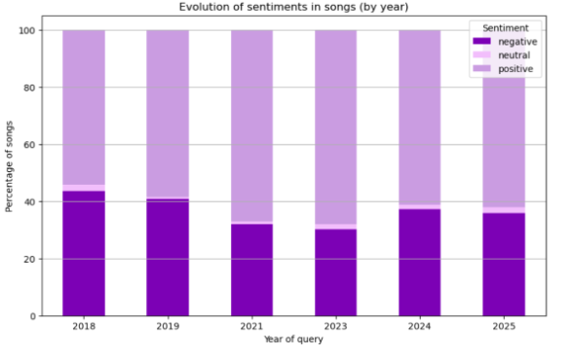
Figure 15 - Trends in song sentiments over time
The chart shows the evolution of song sentiments (negative, neutral, positive) from 2018 to 2025. Negative sentiments have steadily increased, reaching their highest point in 2025, while positive sentiments have slightly decreased over the years. Neutral sentiments remain relatively stable with minor fluctuations. The noticeable rise in negative sentiments in 2023 and 2024 suggests a shift in music themes, with 2025 having a high percentage of negative sentiment songs.
Based on the observed trend, if the increase in negative sentiments continues, it is likely that negative sentiments in songs will keep rising beyond 2025, potentially surpassing 50% of the total by 2027. Positive sentiments may continue to decline slightly, while neutral sentiments could remain stable or decrease as more songs lean towards negative themes. This projection assumes no significant external influences that could alter current trends, such as cultural shifts or major global events.
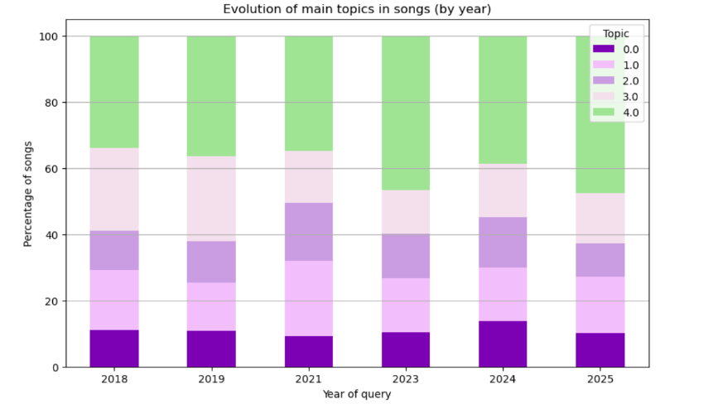
Figure 16 - Trends in song topics over time
The graphic illustrates the distribution of main topics in song lyrics over the years. Topic 4 consistently dominates, while Topic 3 shows a decline around 2023. The other topics remain relatively stable, indicating limited shifts in thematic focus despite yearly changes.
This stability suggests that Topic 4 will likely remain the dominant theme in the near future. The brief dip and recovery of Topic 3 may point to a potential resurgence, but without a clear upward trend, it is expected to hold steady. Since Topics 0 to 2 show no major shifts, we can anticipate that the thematic makeup of songs will remain relatively consistent unless a new cultural movement or trend reshapes lyrical focus.
Topics by popularity within each sentiment
This section seeks to study an aspect that may be interesting: the interaction between the themes used and the feelings generated by a song.
It was decided to leave this analysis for the appendices and not include it in the main body of the project because it was not part of the main objective of the section.

- Sentiment = negative
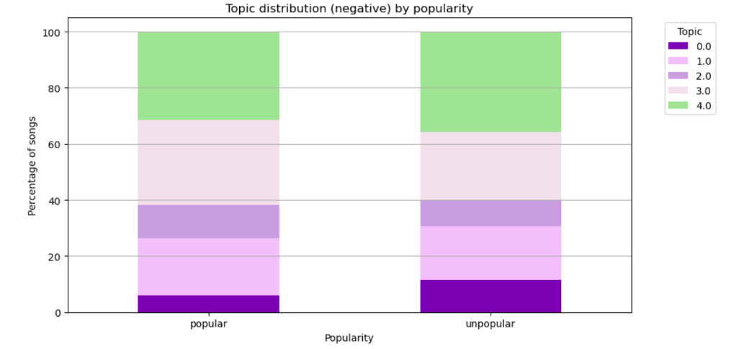
Figure 17 - Negative topic distribution by song popularity
It shows the distribution of main topics in negatively themed songs, comparing popular and unpopular tracks. Overall, the topic proportions are quite similar across both categories, with Topic 4 being the most dominant in both. However, Topic 0 appears slightly more in unpopular songs, while Topic 2 is more frequent in popular ones. This suggests that while negative sentiment songs tend to follow similar thematic patterns regardless of popularity, certain topics (like Topic 2) might be more associated with success, possibly resonating better with wider audiences.
- Sentiment = neutral
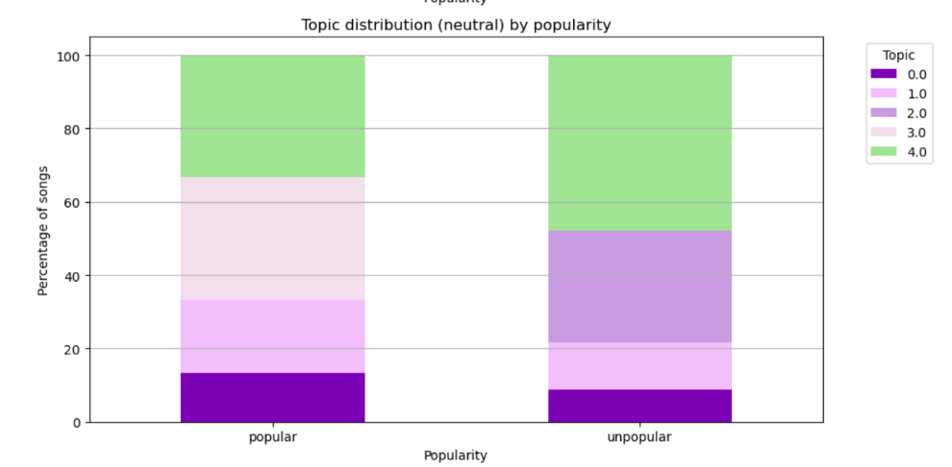
Figure 18 - Neutral topic distribution by song popularity
The chart shows the distribution of main topics in songs with neutral sentiment, comparing popular and unpopular tracks. Topic 4 remains the most common in both categories, but its proportion is slightly higher in unpopular songs. Topic 3 is more prominent in popular songs, while Topic 1 appears significantly more in unpopular ones. This suggests that, among neutrally toned songs, those focusing on Topic 3 may be more appealing to listeners, potentially contributing to their popularity, whereas songs centered around Topic 1 may struggle to gain traction.
- Sentiment = positive
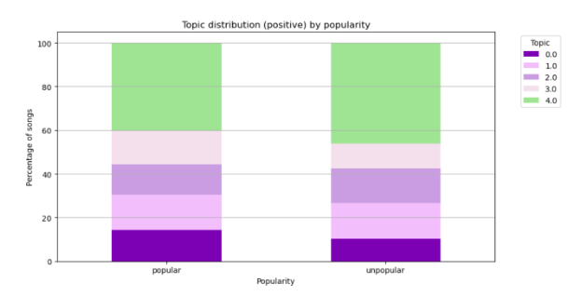
Figure 17 - Positive topic distribution by song popularity
The chart shows the distribution of main topics in songs with positive sentiment, comparing popular and unpopular tracks. Topic 4 is again the most prevalent in both categories, slightly more so in unpopular songs. Topic 0 is more prominent in popular songs, while Topics 1 and 2 appear balanced between the two groups. Topic 3 is slightly more common in popular songs. This indicates that, within positively themed songs, those that emphasize Topics 0 and 3 may have a better chance of achieving popularity, while those dominated by Topic 4, despite being common, may not be as strongly linked to a song’s success.
- Conclusions
Overall, Topic 4 is the most common across all sentiments and popularity levels, suggesting it is widely used but not directly tied to a song’s success. However, certain topics appear more frequently in popular songs depending on the sentiment.
For instance, Topic 2 is more common in popular negative songs, Topic 3 in popular neutral songs, and Topics 0 and 3 in popular positive songs. This indicates that while topic choice doesn't guarantee popularity, it can influence how well a song resonates with listeners.

9.2 Annex 2: Additional word clouds from the lyrics

According to feeling
- Negative
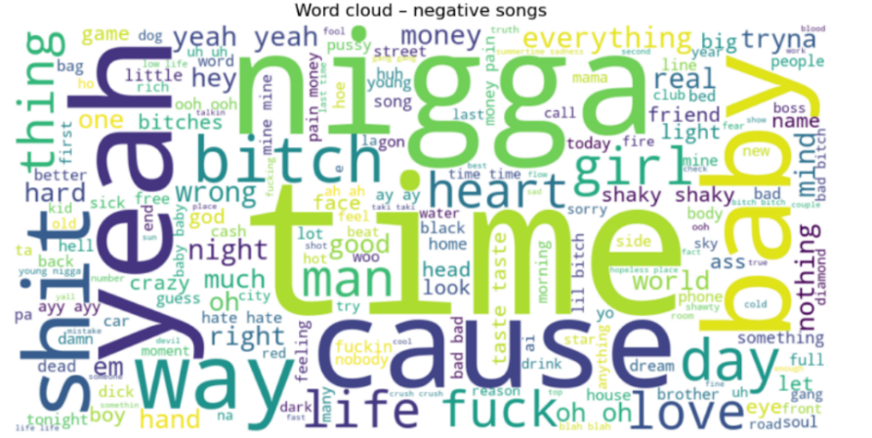
Figure 18 - Common words in negative songs
This word cloud for negative songs highlights frequent use of emotionally charged and explicit language. Words like “shit”, “bitch”, “fuck”, “nigga” and “dick” are prominent, reflecting aggressive or confrontational tones often present in negative lyrics. At the same time, common everyday terms like “time”, “baby”, “cause”, “life” and “love” appear frequently, suggesting that even negative songs often revolve around personal relationships, struggles, and emotional experiences. Overall, the mix of profanity and emotional vocabulary illustrates how negative songs tend to express frustration, conflict, and intense personal themes.
- Neutral
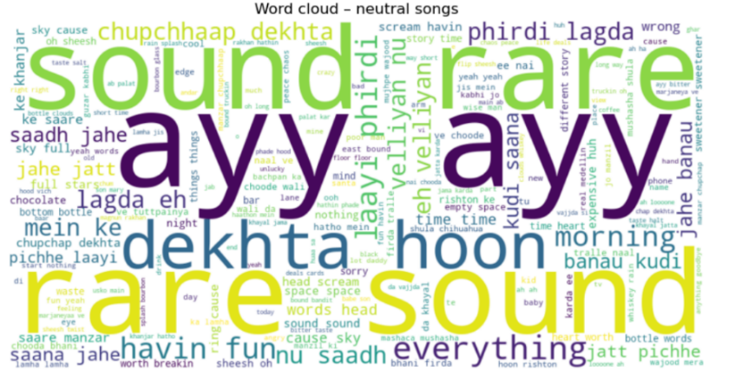
Figure 19 - Common words in neutral songs
For neutral songs, it appears a mix of filler expressions, descriptive terms, and everyday observations. Words like “sound” and “rare” dominate, suggesting a more observational or ambient tone in the lyrics. The presence of multiple non-English words highlights the fact that, all the songs for which no reliable results were obtained, were added to this tag (probably due to the impossibility of translating some terms, such as those we can see in Hindi). Unlike negative songs, there's minimal profanity or emotional intensity, indicating that neutral songs often focus on vibes, daily life, and general commentary without strong emotional extremes.
- Positive
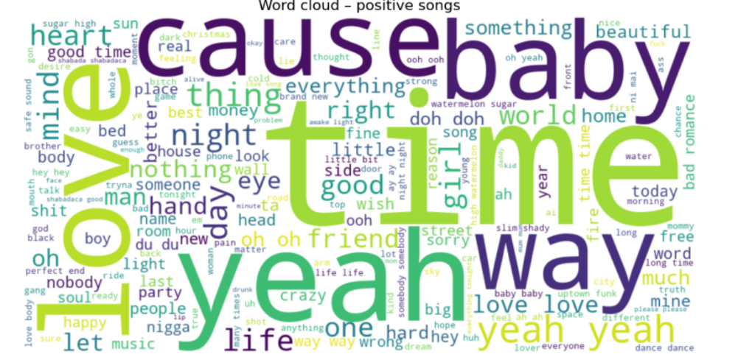
Figure 20 - Common words in positive songs
This word cloud for positive songs highlights themes of affection, joy, and connection. Prominent words like “love”, “baby”, “yeah”, “time” and “friend” suggest a focus on relationships, celebration, and uplifting experiences. The presence of terms like “good”, “beautiful”, “crazy” and “happy” reinforces the overall optimistic tone. Compared to the negative and neutral clouds, the language here is much more emotionally warm and encouraging, reflecting the feel-good nature of positive songs.

Evolution over the years
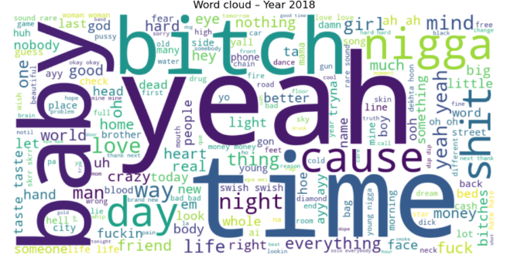  Figure 21 - Most used words in 2018 song lyrics | 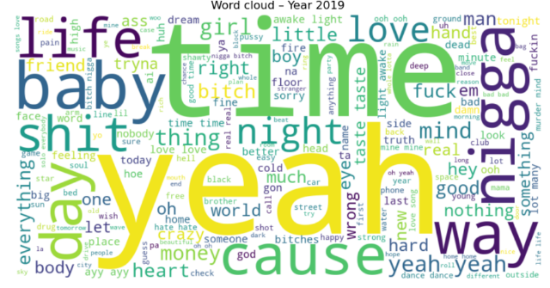  Figure 22 - Most used words in 2019 song lyrics
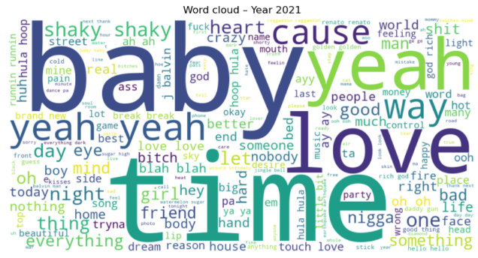  Figure 23 - Most used words in 2021 song lyrics | 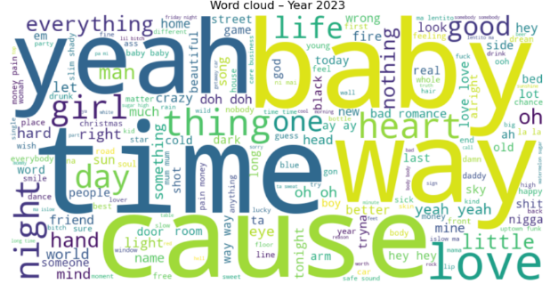  Figure 24 - Most used words in 2023 song lyrics
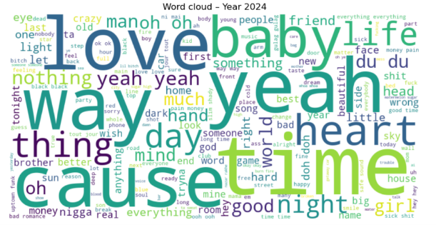  Figure 25 - Most used words in 2024 song lyrics | 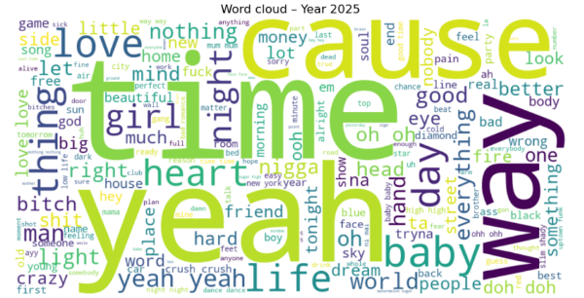  Figure 26 - Most used words in 2025 song lyrics
Across the years from 2018 to 2025, the word clouds show a notable consistency in commonly used words in song lyrics, with terms like “yeah”, “time”, “baby”, “love” and “cause” appearing prominently every year. These words point to recurring themes in music such as relationships, personal reflection, and emotional expression. Over time, explicit or aggressive language like “bitch”, “shit” and “fuck” seems to decline in visual prominence, particularly after 2019, suggesting a possible softening in lyrical tone or a shift toward more mainstream, accessible content.
From 2021 onward, there is an increased presence of emotionally positive or neutral words like “heart”, “life”, “friend” and “beautiful”, aligning with broader trends toward emotional vulnerability and introspection in modern music. The term “baby” grows increasingly central, indicating a persistent focus on romantic or intimate themes. Overall, while the vocabulary remains rooted in core emotional and relational concepts, there is a subtle evolution toward more positive and reflective language in recent years.

9.3 Annex 3: Additional association rules

MID as consequent
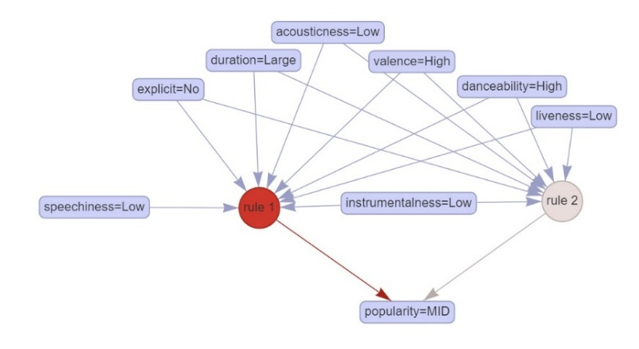
Figure 27 - Rules that have "MID" as consequent
This association rules identifies the characteristics that predict a song being classified as mid in popularity. The rule most strongly linked to this outcome (rule 1) is activated when a combination of features are present: low speechiness, low acousticness, no explicit content, long duration, high valence, high danceability, low liveness, and low instrumentalness. These attributes together lead to a mid-level popularity prediction, suggesting that songs with these features are neither hits nor flops, but achieve moderate success.
Rule 2 overlaps with rule 1 in some conditions (like low instrumentalness, high danceability, and low liveness), reinforcing their relevance. The strong connection between rule 1 and mid popularity (indicated by the bold red arrow) shows a higher confidence in this pattern, making it a useful insight for anticipating songs that will perform decently but not exceptionally.

MID-HIT as consequent
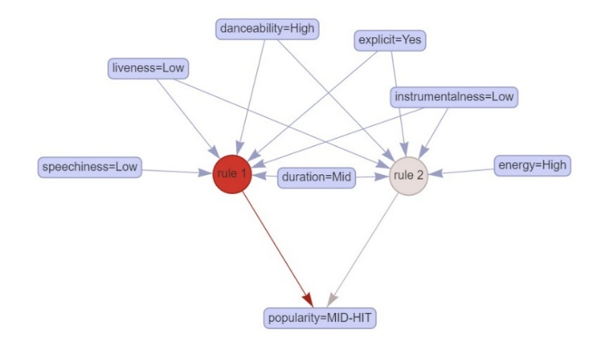
Figure 28 - Rules that have "MID-HIT" as consequent
This association rule graph identifies the characteristics that predict a song being classified as a mid-hit, a level just below a full hit in popularity. Rule 1 is the strongest contributor and is activated by the combination of high danceability, low speechiness, low liveness, mid duration, and explicit lyrics. These features collectively suggest a song that is energetic and optimized for rhythmic appeal (traits commonly found in commercially successful music).
Rule 2 overlaps slightly, adding conditions like high energy and low instrumentalness, further reinforcing a dynamic and vocal-driven profile. The strong red arrow from rule 1 to “popularity = MID-HIT” indicates high confidence in this association. This suggests that songs with these traits have a strong potential to perform well and reach notable, though not top-tier, success.

9.4 Annex 4: Mock-up demonstration
Here is the demonstration of the mock-up.

9.5 Annex 5: GitHub repository

The GitHub repository is accessible via this link.

10. Bibliografía
Alessandro, M. (6 de November de 2021). webscraping_lyrics. Obtenido de GitHub: https://github.com/a-montanari/webscraping_lyrics
Arora, M., & Rani, R. (2024). Predicting Song Popularity Using Data Analysis. Recuperado el February de 2025, de ResearchGate: https://www.researchgate.net/publication/383709855_Predicting_Song_Popularity_Using_Data_Analysis
Beley, D. (28 de September de 2024). lastfm-scraper. Recuperado el March de 2025, de GitHub: https://github.com/dbeley/lastfm-scraper
Chen, D., M. Schuster, C., Satish, A., Khanbayov, R., & Groh, G. (2023). Beats of Bias: Analyzing Lyrics with Topic Modeling and Gender Bias Measurements. Technical University of Munich.
Developers, S.-l. (January de 2025). scikit-learn: Machine Learning in Python (versión 1.6.1). Recuperado el March de 2025, de Scikit-learn: https://scikit-learn.org/stable/
Du, J. (2024). Sentiment Analysis and Lyrics Theme Recognition of Music Lyrics Based on Natural Language Processing. Journal of Electrical Systems.
Figma. (15 de June de 2021). Figma Basics Español: Primeros pasos en Figma. Recuperado el April de 2025, de Figma: https://www.figma.com/community/file/923140611594993345/figma-basics-espanol-primeros-pasos-en-figma
Logan, B., Moreno, P., & Kositsky, A. (2004). Semantic Analysis of Song Lyrics. ResearchGate.
Pachet, F. (2021). Hit Song Science. Sony CSL. Obtenido de https://francoispachet.fr/wp-content/uploads/2021/01/pachet-11a.pdf
Pham, J., Kyauk, E., & Park, E. (2015). Predicting Song Popularity. Stanford University. Retrieved from https://cs229.stanford.edu/proj2015/140_report.pdf
Prevedello, G., Blin, I., Monechi, B., & Ubaldi, E. (2024). Lyrics for Success: Embedding Features for Song Popularity Prediction. En A. f. Linguistics (Ed.), Proceedings of the 3rd Workshop on NLP for Music and Audio (NLP4MusA), (págs. 75–80). Oakland, USA.
Refinery, I. (16 de August de 2019). Association Rule Mining. Recuperado el February de 2025, de Nextjournal: https://nextjournal.com/association-rule-mining/association-rule-mining
Roque López, J. (2021). Técnicas de selección de variables en regresión lineal múltiple. Huelva: Universidad de Huelva y Universidad Internacional de Andalucía.

